Using LLMs to Build Business Visualisations
19774158

Abstract

The advent of large language models (LLMs) has revolutionized the field of natural language processing and data analysis. This paper explores the fine-tuning of LLMs specifically designed to generate data visualizations using the Pandas library in Python.
This research not only highlights the potential of LLMs in automating data visualization tasks but also addresses challenges in ensuring output relevance and correctness. The findings underscore the transformative impact of fine-tuned LLMs on data analysis workflows, enabling users to harness the power of data visualization with increased efficiency and accessibility. Future work will explore expanding the model's capabilities to handle more complex datasets and advanced visualization techniques, further bridging the gap between natural language processing and data science.

In the current digital age, Large Language Models (LLMs) are prevalent in improving businesses, ranging from customer support bots, in-house chatbot, and assistant for content creations. In this project, we will look at training several LLMs to produce graphs and tables from business data. We will look to start with LLaMA 3.1 from Meta and Mistral, an LLM which rivals the performance of LLaMA. In addition, multiple discriminant functions will need to be developed to assess how accurate a visualisation is from the prompt, which will be used in training alongside the occasional human feedback to ensure the LLM is not being trained in the wrong direction.

Introduction

Literature Review

This literature will cover the 2 models to be investigated – LLaMA 3.1 and Mistral.

The LLaMA 3.1 model is developed by Meta and publicly available in 2023. It is part of the LLaMA (Large Language Model Meta AI) series. It features an expanded context length of up to 128,000 tokens, meaning it handle long and complex inputs (Neurohive, 2024). The LLaMA model can be used with 8 billion, 70 billion, or 405 billion parameters. We will be using the model with 8 billion parameters due to computing constraints. The model with 405 billion parameters has been shown to perform comparably or better than other powerful models. For example, the IFEval test scored LLaMA 3.1 at 88.6 – higher than GPT-4 Omni at 85.6, and in the MMLU test saw LLaMA 3.1 score 88.6, comparable to GPT-4 Omni’s 88.7 score. However, we will have to see its performance with only 7 billion parameters.

Mistal is another state-of-the-art language model developed by Mistral AI. It was also released in 2023 along with a scientific paper on it’s capabilities and performance (Jiang et al., 2023). Much like the small LLaMA model, Mistral has 7 billion parameters and leverages 2 unique mechanisms – grouped-query attention (GQA) which speeds up the inference speed and allows for higher batch processing and sliding window attention (SWA), which can handle longer token sequences at a lower computational cost. What is fascinating about Mistral is that during testing, its performance was higher than that of LlaMA 2’s performance – scoring consistently higher on MMLU, PIQA, and many other tests. It will be interesting to observe whether a fine-tuned Mistral model will outperform a LlaMA model.

It is simple to obtain these models through a free download, however the most challenging aspect is the fine-tuning of these models. It is imperative that there is a robust marking system to mark the code that is outputted from the models and ensure it accurately reflects the query fed into the model and matches the intended aesthetic. According to research, these LLMs to produce high-quality code can be achieved by combining automated discriminant functions and human feedback. This approach ensures that the model not only learns from a large corpus of data but also refines its outputs based on non-quantifiable metrics.

Discriminant functions play a crucial role in evaluating the quality of the generated code. These functions often involve using automated tools like compilers to assess whether the code is syntactically correct and is of readable/debugging quality. A paper published recently in June 2024 looked at using compilers and vision-language models to assess the quality of SwiftUI code (Wu et al., 2024). Researchers called this method UICoder, which for the paper’s case, aggressively marked front-end user interface code. After scoring, outputs were filtered and removed of any duplicates to create refined datasets of code the machine can use to create new snippets of code. Swift Compiler was used to assess whether the code compiled or not, and a ‘CLIP score’ was calculated by a vision-language model to mark how closely the code resembled the query.

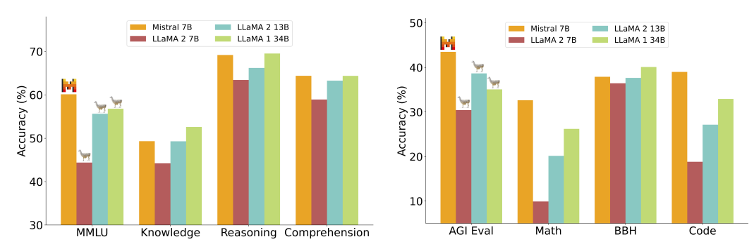
Mistral outperforming other LLMs across different metrics

Another paper utilising discriminant functions when training LLMs is (Wang et al., 2023). The researchers opted to use GPT 4 as the discriminant, which is done by providing pairs of input strings and answers to GPT 4 and asking it to compare responses, give written feedback and a numerical score, and used their own custom model by the name of Falcon-I-CnR to review the feedback and revise the answer. This model was trained to follow revision instructions, and as such was able to improve the feedback. Based on human feedback, the revised responses were better than the original response 57% of the time.

While the above articles contain fascinating ways to employ automated discriminant functions, it is essential to also utilise human feedback during LLMs. This is to ensure the model is factually grounded and does not ‘hallucinate’ nonsensical results that is not factually grounded. There is an example of combining the reinforcement learning for an LLM with human feedback and found that using reinforcement learning from human feedback (RLHF) resulted in up to 34.8% less hallucinations (Yu et al., 2024). In the case of this paper, this was implemented by asking humans to correct the output of an LLM for any solutions (e.g. the LLM claiming there are people in the picture when there are none). While it was also possible to use a numerical value to grade the picture, researchers felt the number was ambiguous on what needed to be improved. This human feedback was implemented during the initial part of fine-tuning. After the LLM matures, the human is no longer necessary upon further training. Using the data annotated via human feedback, the hallucination rate is noticeable lower than without human feedback.

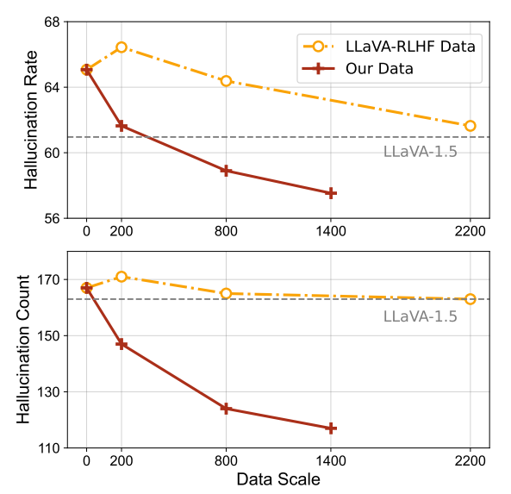
Comparing the same LLaVA model with and without RLHF

Now looking at a paper that looks at a similar topic to this project - this paper from 2023 investigated data visualisation creation with LLMs. They have titled their model ‘ChartGPT’ (Tian et al., 2023), as they also looked at creating Python data visualisations. The paper also delves into a detailed pipeline broken down into subtasks on the data generation and training processes. Researchers would feed the specific query into the model, and the model would be tuned to improve 3 subtasks: understanding the context of the data, the transformations required of the data, and the necessary chart type to output.

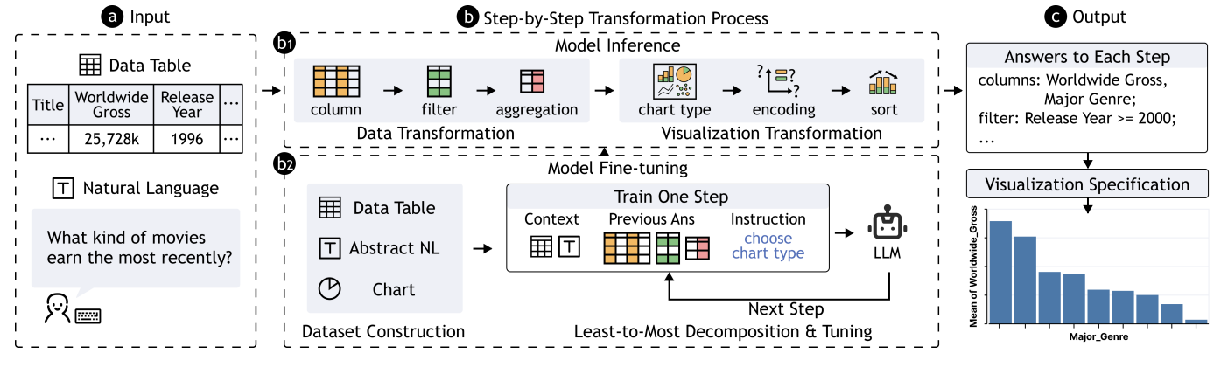
Training Pipeline of ChartGPT

To construct their database, the researchers had to ensure that there was a fair spread of different charts, as well as difficulty constructing them – the researchers split this into easy, normal, hard and extra hard based on the number of filter, aggregation, and sort operations. In addition, the text inputs were also engineered carefully – while some users may be very formal with their input string (e.g. Can I have the number of X), most users used shorter prompts (e.g. number of X).

LLM Generation – data augmentationhttps://arxiv.org/pdf/2403.01632

Methodology

Data

There are 2 types of data that we need to collect for training.

- Business data that the model will be querying from

From the available business data, we have extracted data from 3 different sources: Square for merchandise payments, the Photobooth online portal for photo purchases, and the roster spreadsheet. These three data sources are sufficient to conduct analysis on product trends and employee performance. Data from these sources is then combined into 1 file. For this experiment we have used data from 10/06/24 to 25/08/24.

- Prompt-Code pairing

This is the most important data as it will be used to train the LLM. It will be learning how to output visualisations using queries in Python, based on queries made to the AI. Each entry into the training data in this experiment contains an instruction on what information we want to the database (e.g. total sales in August), input of all the valid columns of the table, and finally an output, which is a Pandas code snippet that we want the LLM to produce.

It is crucial for the output of the AI to be consistent, adjacent to the input query, and of high quality. Each visualisation must have the correct colours, labels and company logo. As such, it must be ensured that the models be only trained with only the highest quality code.

The following principles have been designed for the code being fed into the model. They have been split into three categories: must follow regardless of prompt, dictatable by prompt, and code quality.

Must Follow | Dictatable by Prompt | Code Quality
Must use company font (Manjari) | Colour must match the prompt. If colour is not specified, must use one of company’s shade of purple | Generous line spacing
Must display company logo in corner | Type of plot must match the prompt. If not specifically stated, the visualization has to be the most appropriate type (bar plot, line plot, etc.) depending on the query | Sensible variable names
Size of all plots must be stated to be1000x800 | Titles and axes need to be as close to the prompt as possible. Visualization may have no axes or titles if stated in query | No comments

Principles in the ‘Must Follow’ category have been applied to each code segment to keep code quality consistent regardless of the prompt. The dictatable features have been designed to be flexible of the visualization produced and cater as much as possible to the prompt. Lastly, principles have been set for code quality not only for the AI model to learn from the code more effectively, but for other scientises to be able to interpret the code if needed.

To train the model in a diverse data, we have elected to add variety to the code inputs in the following ways:

- Type of queries – Ensuring there is a wide range of content being queried for, e.g. whether it is asking for employee performance, performance during specific days
- Object Oriented programming and state programming – There are 2 ways of producing plots in Matplotlib – one method uses object oriented programming while the other utilises state-based programming. To ensure the model is knowledgeable on a wider range of syntax, we have fed code with both types of programming into the model.
- Different column name and order – To let the model understand the relationship between words in the query and the different columns, we have elected to have variations of the dataframe name as the input, and have them in different orders. This made the model have a better understanding of the relationship between the query and the columns regardless of the order
- Colour
- Date Filter
- Type of Plot
- Title and Axes Label and Visibility
- Coding Style – Object Oriented based and State based

Describe manipulations to data
Describe flagging

The

Training

Inference

Literature Review

